(6).When start button is pressed a motor goes ON it remains ON until the stop

Button is pressed,this motor can not be started sgain before 5 min. Are

left when it is stop previously.

DI:-I:0.0/0-START DO:-O:0.0/0-MOTOR

I:0.0/1-STOP

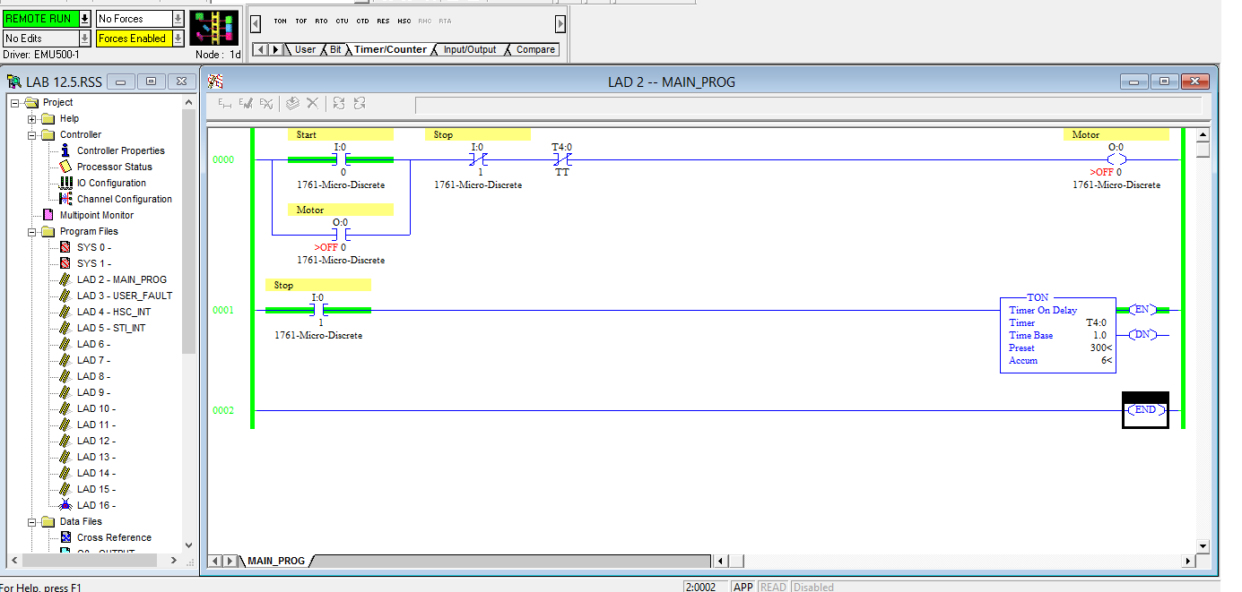

(7).Draw a ladder diagram for container packing system whose schimatic given in the

Fig. the function of the system as follows:

Whenever a container is placed on the conveyor its presence will be sensed

by a proxy-1 sensor and the conveyor belt will start when container reaches to spray nozzle position the conveyor stops and the spray nozzle will apply paint on the container for 5sec.After this the conveyor restart and the container taken to label is been placed for 2sec.After label is been placed for 2sec.After label is been placed on the container the conveyor carries the container to the packing system,where the ejector will eject the container from the conveyor belt and move it to packing.for powering up the system seprated start and stop button are provide.

DI:-I:0.0/0-START DO:-O:0.0/0-conveyor

I:0.0/1-STOP O:0.0/1-spray

I:0.0/2-Proxi 1 O:0.0/2-Label

I:0.0/3-s proxy O:0.0/3-Ejector

I:0.0/4-L Proxi

I:0.0/5-proxi2

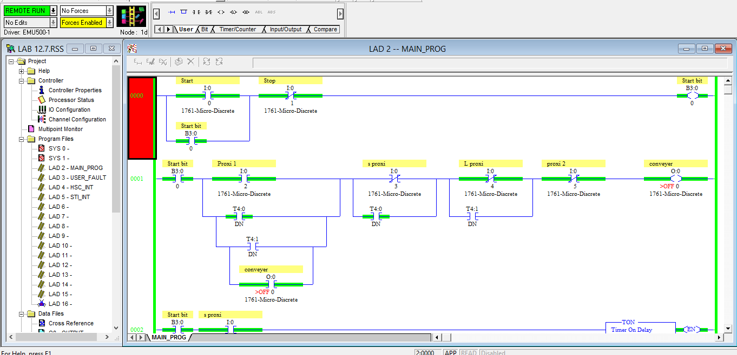

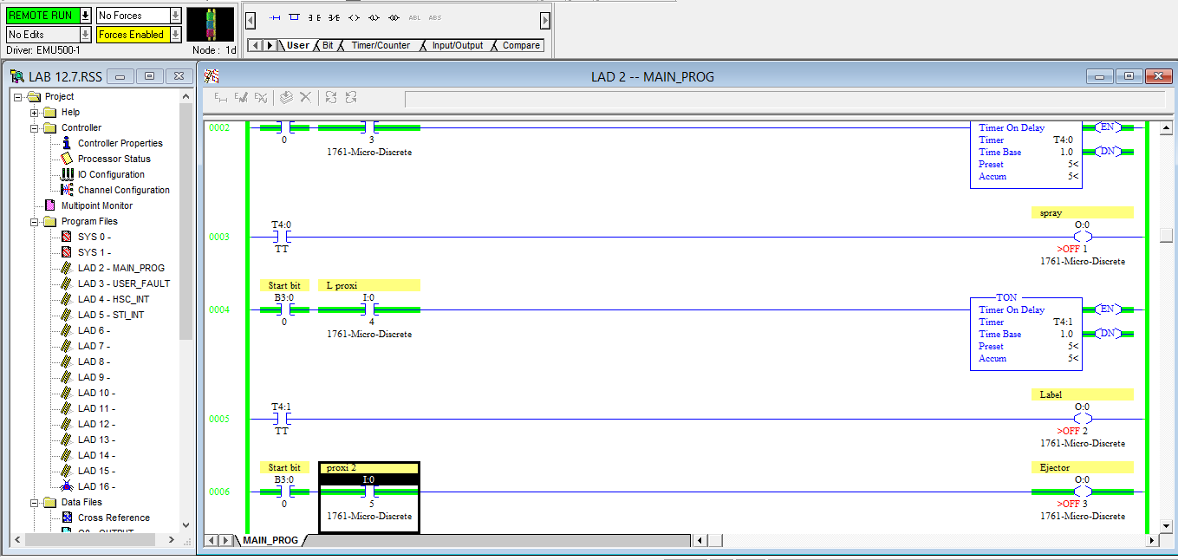

(8).Write a ladder to enable a traffic controller using compare instructions.

DI:-I:0.0/0-START DO:-O:0.0/0-RED

I:0.0/1-STOP O:0.0/1-YELLOW

0:0.0/2-GREEN

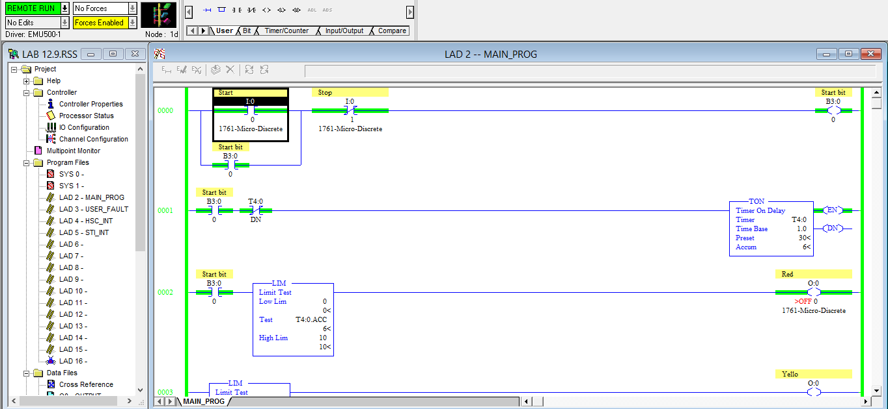

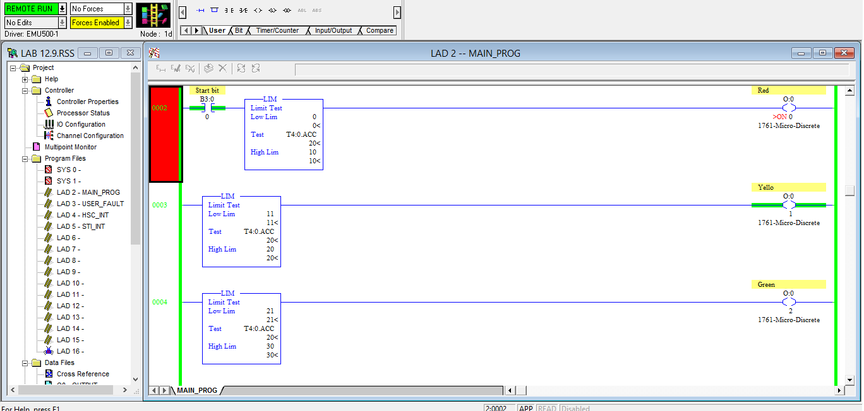

(9).When a light turned OFF in a bulding and a exit door light remain ON for on

additional 42sec.In additional the parking plot lights are to remain ON for

an additional 3min. after the door light goes OFF.Draw a ladder diagram

for this operation.

DI:-I:0.0/0-sw1 DO:-O:0.0/0-Door light

O:0.0/1-parking light

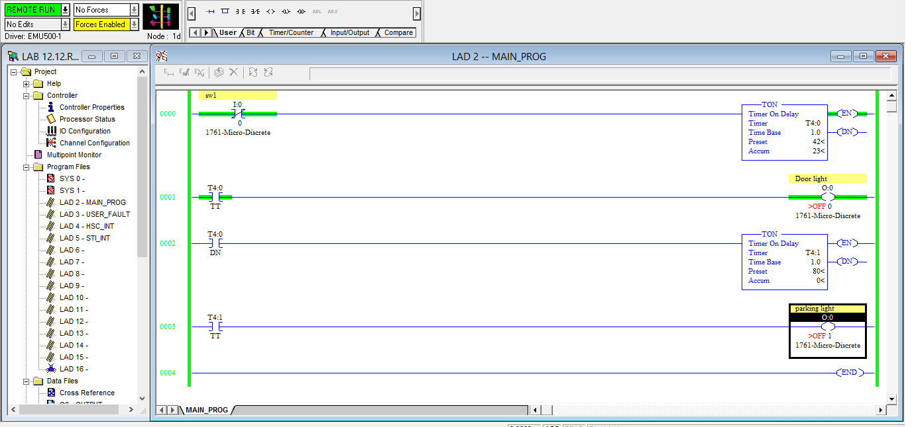

(10).When the start button is depressed output M goes ON 5sec later and N goes ON.When stop is pushed both M & N go OFF.In addition,6sec after M & N go OFF,fan F which had previously been OFF goes ON.F remains ON until the start button is again depressed.

DI:-I:0.0/0-START DO:-O:0.0/0-N

I:0.0/1-STOP O:0.0/1-M

O:0.0/2-F

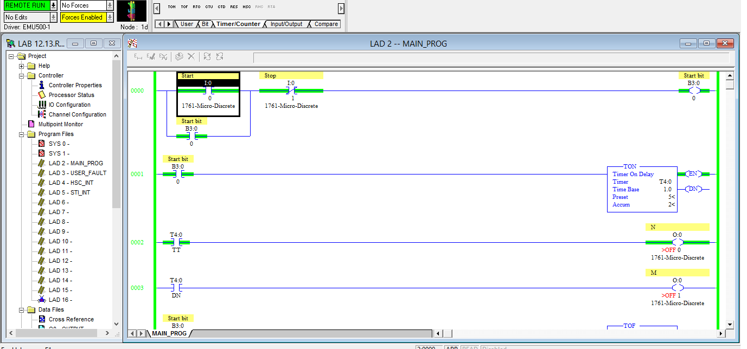

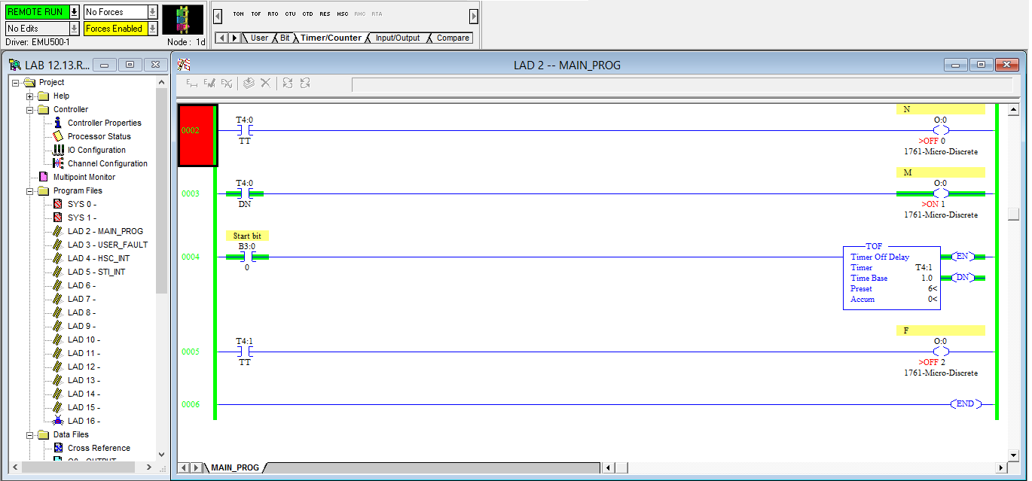

(11).O=(A’B + BC)(CD + E)’

DI:-I:0.0/0-A DO:-O:0.0/0-O

I:0.0/1-B

I:0.0/2-C

I:0.0/3-D

I:0.0/4-E

